*We should avoid tightly coupled code*

* Creating an object of a class with new keyword results in a class being tightly coupled to another class.

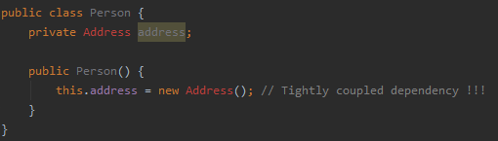

*Dependency inversion principle helps to create loosely coupled software modules*

*Modules should depend on abstraction !!!*

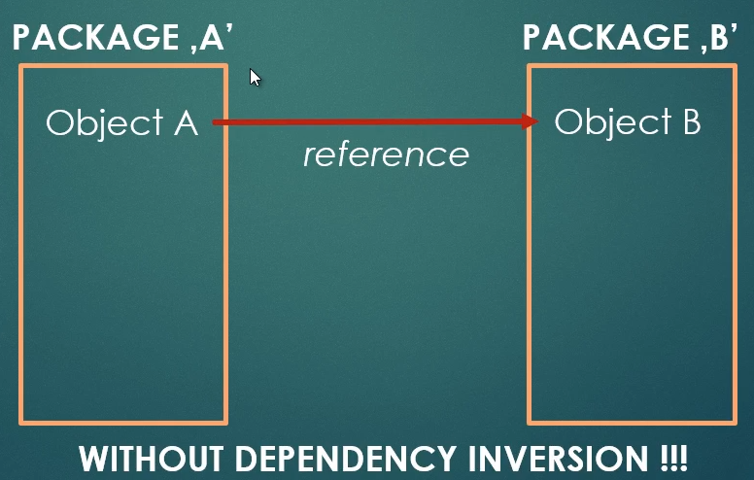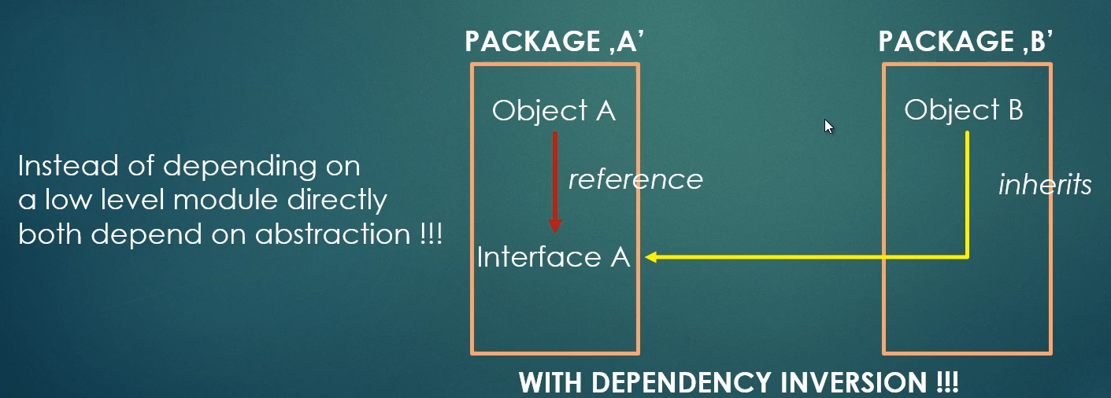

*In object oriented programming, we can implement inversion of control several ways*

* Using design patterns: factory, template or strategy patterns
* Using service locator pattern
* Using dependency injection